Linear Regression
Bias - An intercept or offset from an origin. Bias is a parameter in machine learning models
Feature - An input variable to a machine learning model
Label - The "answer" or "result" portion of an example.
Linear Regression - A type of machine learning model in which both of the following are true:
- The model is a linear model.
- The prediction is a floating-point value
Parameter - The weights and biases that a model learns during training
Weight - A value that a model multiplies by another value

Loss
Mean Absolute Error (MAE) - The average loss per example when L₁ loss is used
Mean Squared Error (MSE) - The average loss per example when L₂ loss is used
L1 - A loss function that calculates the absolute value of the difference between actual label values and the values that a model predicts
L2 - A loss function that calculates the square of the difference between actual label values and the values that a model predicts.
Loss - During the training of a supervised model, a measure of how far a model's prediction is from its label.
Outlier - Values distant from most other values
Prediction - A model's output

Parameters
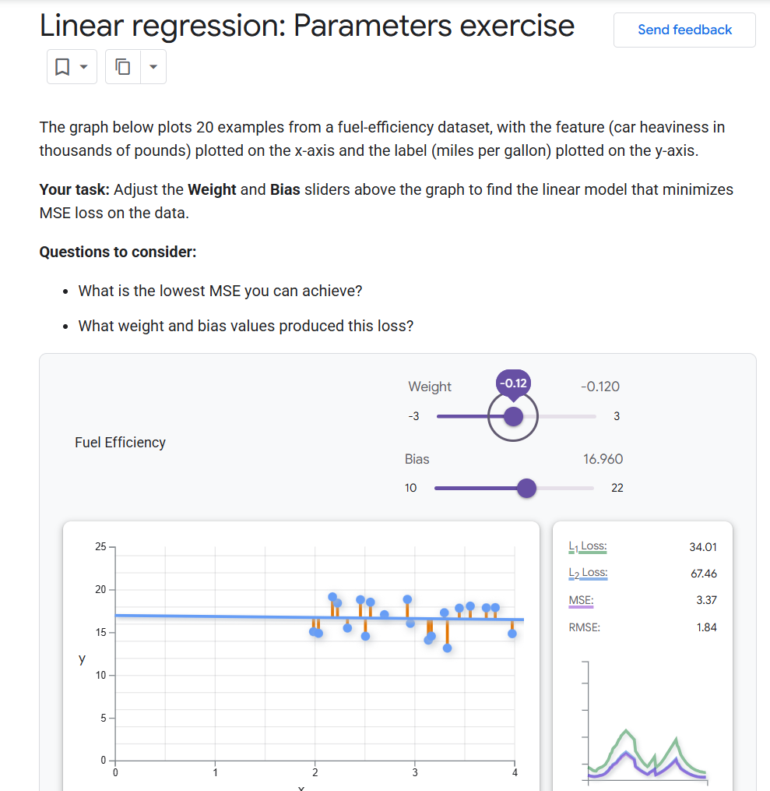

Gradient Descent
Convergence - A state reached when loss values change very little or not at all with each iteration
Convex Function - A function in which the region above the graph of the function is a convex set
Gradient Descent - A mathematical technique to minimize loss
Iteration - A single update of a model's parameters—the model's weights and biases—during training
Loss Curve - A plot of loss as a function of the number of training iterations

Hyperparameters
Batch Size - The number of examples in a batch
Epoch - A full training pass over the entire training set such that each example has been processed once
Generalize - A model's ability to make correct predictions on new, previously unseen data
Hyperparameter - The variables that you or a hyperparameter tuning service adjust during successive runs of training a model
Iteration - A single update of a model's parameters—the model's weights and biases—during training
Learning Rate - A floating-point number that tells the gradient descent algorithm how strongly to adjust weights and biases on each iteration
Mini-batch - A small, randomly selected subset of a batch processed in one iteration
Mini-batch Stochastic Gradient Descent - A gradient descent algorithm that uses mini-batches
Neural Network - A model containing at least one hidden layer
Parameter - The weights and biases that a model learns during training
Stochastic Gradient Descent - A gradient descent algorithm in which the batch size is one

Gradient Descent
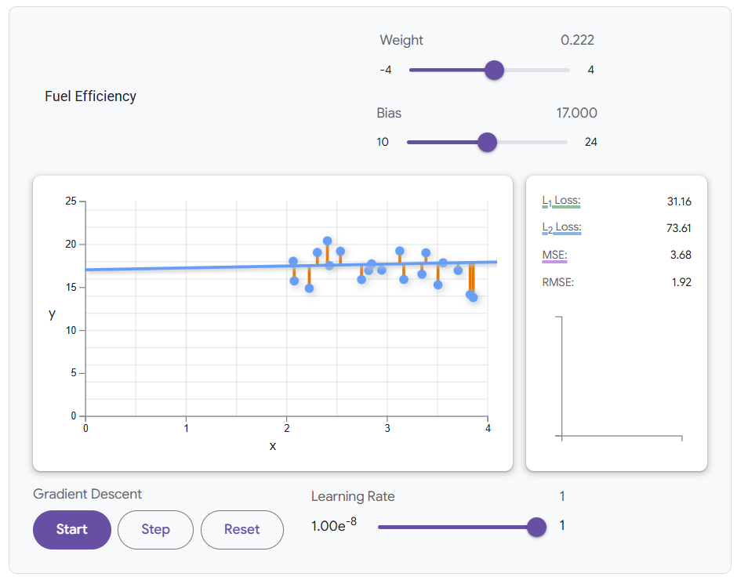
Programming Excersice

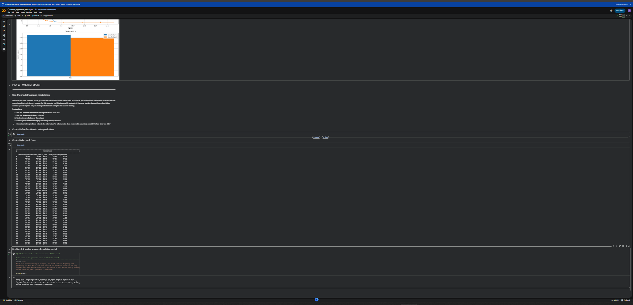

Test Your Knowledge



